
FURTHER MATHEMATICS
TRIAL EXAMINATION 2
SOLUTIONS
2005

_____________________________________________________________________

Section A - Core - solutions

Question 1

- Using a calculator and 1-Var stats, the mean = 47.2.
(1 mark)
and the standard deviation = 4.2 (correct to one decimal place).
(1 mark)

- Again, using a calculator and 1-Var stats, 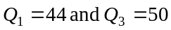, so the interquartile range is 6.
(1 mark)

- The independent variable is x, the number of hours a week of physical activity engaged in by students since it is reasonable to assume that the weight of a student to some degree depends on this. Also the physical activity per week is located on the horizontal axis of the scatterplot.
(1 mark)

- For a least squares regression line to be calculated, it has been assumed (by looking at the scatterplot) that the relationship between the number of hours of physical activity that a student engages in and their weight is linear.
(1 mark)

- Use a calculator to generate these values. The equation of the least squares regression line is given by
(2 marks)
- The coefficient of determination is given by 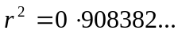
So 91% of the variation in the weight of these students can be explained by the number of hours a week that they engage in physical activity.
(1 mark)
- For Student A, the number of hours of physical activity engaged in a week is 7. According to the least squares regression line
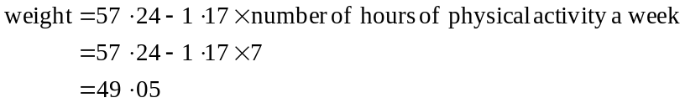
The actual weight of Student A is 50. So Student A’s weight is underestimated by 0.95kg.
(1 mark)
(Full marks if using incorrectly calculated least squares regression line.)

Question 2

 | boys | girls
More than 12 hours a week | 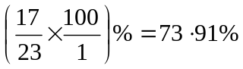 | 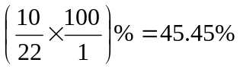
Less than 12 hours a week | 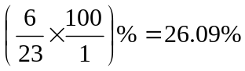 | 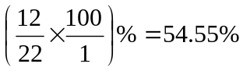

(2 marks)

- By percentaging the table using column percentages, the two categories of students we are comparing are boys and girls.
(1 mark)

Question 3

- The data can be described as seasonal.

(1 mark)

- The three median smoothed line is shown as the thicker line on the graph below.
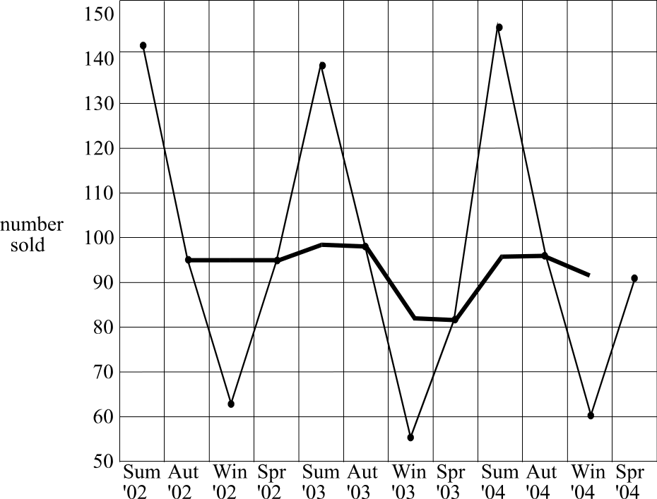

(2 marks)
Total 15 marks

Module 1: Number patterns and applications

Question 1

- 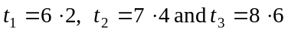
There is a common difference of 1.2. So the distance from the movie screen to the back of the fourth row of seats is 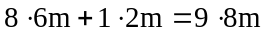.

(1 mark)
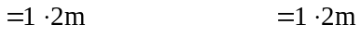

(1 mark)
- Since there is a common difference between each of 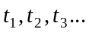 the sequence is arithmetic.
(1 mark)
- Method 1
Since we have an arithmetic sequence with 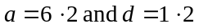,
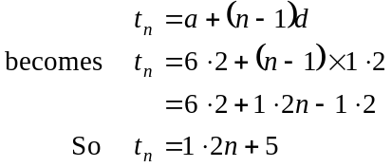
(1 mark)
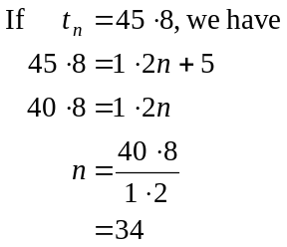
There are 34 rows of seats in the movie theatre.
(1 mark)

Method 2
Using a graphics calculator generate the sequence beginning with 6.2 and continue to add 1.2.
(1 mark)
Start counting each term that you generate so that 6.2 is the first term and every 1.2 that you generate creates the next term and so on until you reach 45.8.
It is the 34th term.
There are 34 rows of seats in the movie theatre.
(1 mark)
- We know that the sequence is arithmetic so that the required difference equation will be of the form
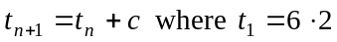
We know that the amount added on to each term is 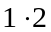. So 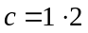.
So the required difference equation is

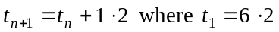
(1 mark)

Question 2

- Method 1
If there were 6% less people at the second session, we can say that this is the same as 94% of 250.
So, 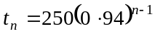 since we have a geometric sequence
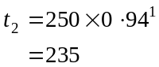
(1 mark)

Method 2
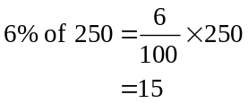
There were 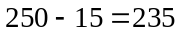 people at the second session.
(1 mark)

Method 3
Use a calculator to generate the sequence by multiplying 250 by 0.94 each time.
The second term is 235.
(1 mark)

- Method 1
From part a.,
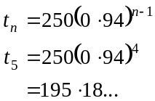
There were 195 (to the nearest whole number) people at the fifth session.
(1 mark)

Method 2
Use a calculator to generate the sequence by multiplying by 0.94 each time.
The fifth term is 195.18…
There were 195 (to the nearest whole number) at the fifth session.
(1 mark)

- We have a geometric sequence
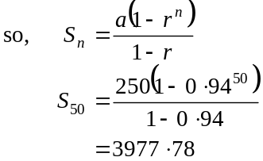
(1 mark)
There were 3978 people in total.
(1 mark)
- Method 1
Use a calculator to generate the sequence and count the terms. (1 mark)
At the 28th session, the number of people attending would first drop below 50.
(1 mark)

Method 2
We have a geometric sequence so
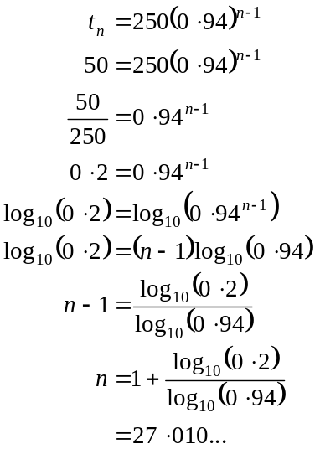
(1 mark)
So the first time that the number of people attending dropped below 50 was at the 28th session.
(1 mark)

Question 3

- 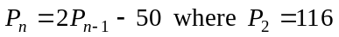
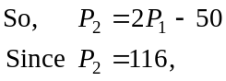
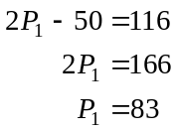
So 83 people attended the first session in Theatre B.
(1 mark)

- In theatre A, the first five sessions had
There were 1109 people at the first 5 sessions in Theatre A (to the nearest whole number).
In theatre B, the first five sessions had
(1 mark)
So, Theatre B had 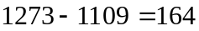 more people in attendance on the first day.
(1 mark)
Total 15 marks

Module 2: Geometry and trigonometry

Question 1

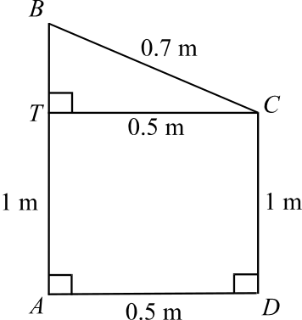
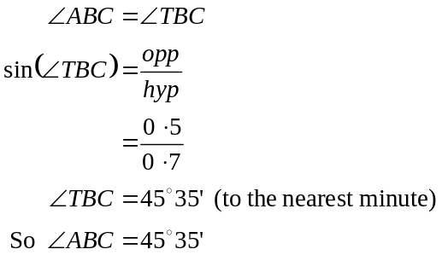

(1 mark)

- In 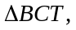
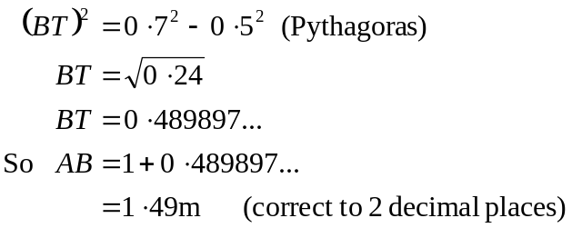
(1 mark)

Question 2
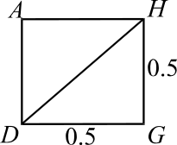
- In DGHA

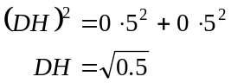
(1 mark)
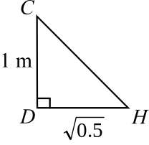
In 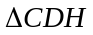

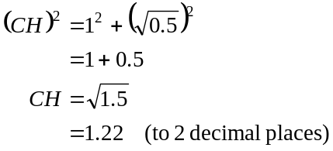
(1 mark)

- Area of base of actual bin
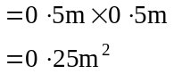

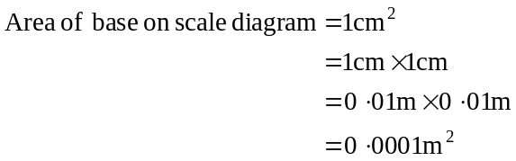
(1 mark)
Now 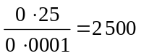. Since we are dealing with area we need to take the squeare root of this. Now 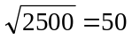.
The scale used is 1:50.

(1 mark)

Question 3

- The bearing of A from B is 339°.
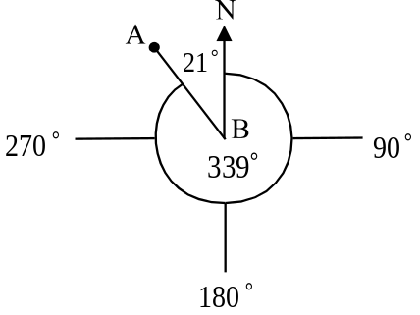

(1 mark)

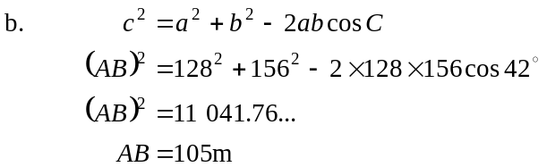 (1 mark)
(to the nearest metre)
(1 mark)

- Using the sine rule
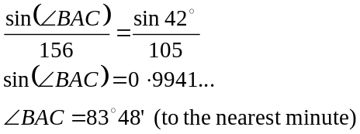
(1 mark)
(1 mark)
- 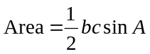
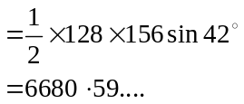
Area is 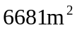.(to the nearest square metre) (1 mark)

Question 4

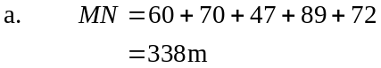
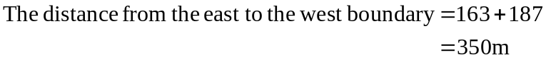
(1 mark)
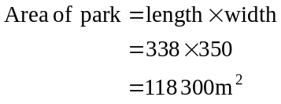
(1 mark)

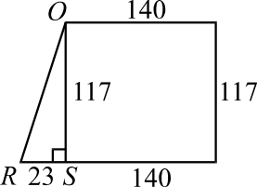
- In 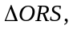
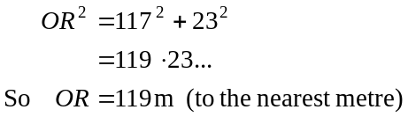
(1 mark)

Total 15 marks
Module 3: Graphs and relations.

Question 1

- Three weeks after it opened, the gym had 50 12-month memberships.
(1 mark)

- During the 11th week there were 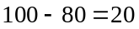 12-month memberships taken out.
(1 mark)

- The greatest number of 12-month memberships taken out were taken out in the first week since the graph is steepest during that first week.
(1 mark)

Question 2

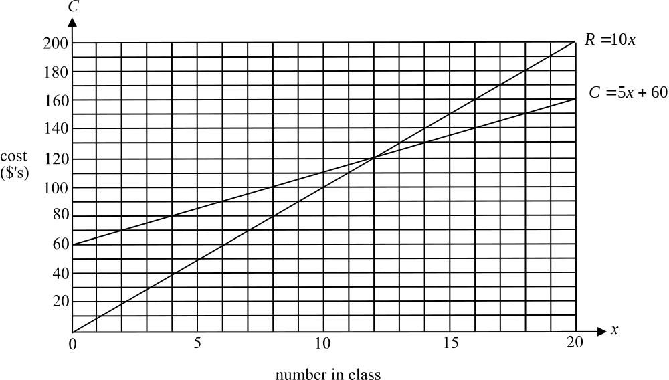

(2 marks)

- i. Using the graph we look at the point of intersection of the two lines.
It occurs at 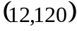.
There are 12 class members needed for the class to break even.
(1 mark)
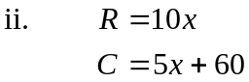
At break-even point, 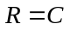.
(1 mark)
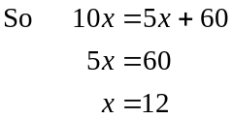
So there are 12 class members needed for the class to break even.
(1 mark)

- When 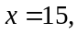 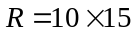
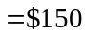
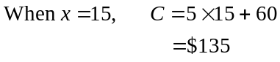
(1 mark)
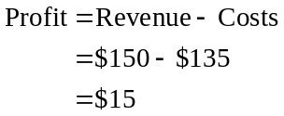
(1 mark)

Question 3

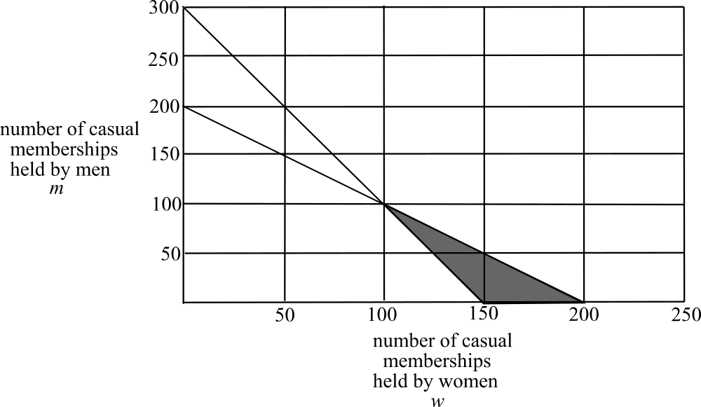

The feasible region is shaded on the diagram above.
(1 mark)
- 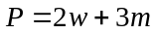
From the diagram, the corner points of the feasible region occur at 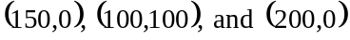.
(1 mark)
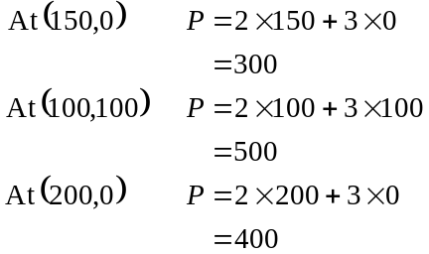
The maximum profit that can be achieved is $500.
(1 mark)

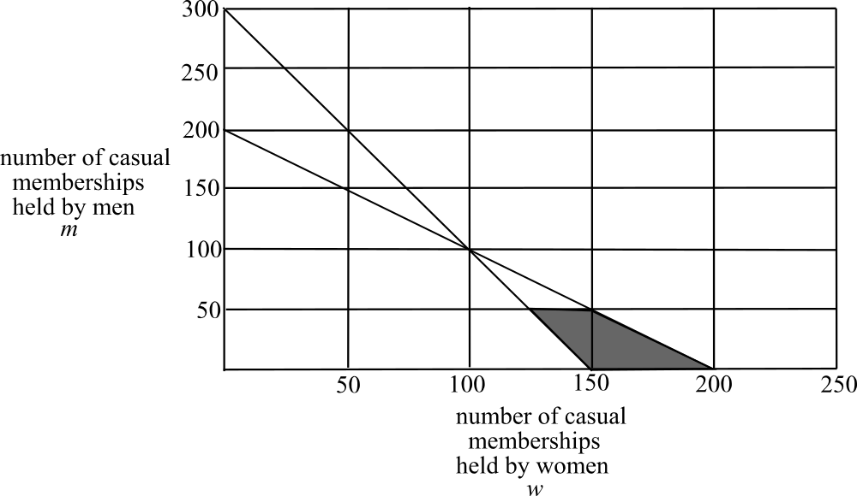

This new constraint of 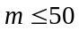 introduces 2 new corner points on the feasible region and eliminates the corner point (100,100) that we used to obtain the maximum profit.
Now,
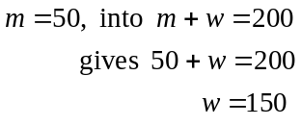
So (150,50) is one of the two new corner points.
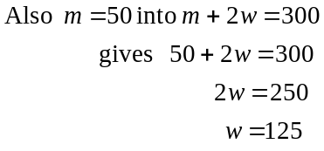
So (125,50) is the other new corner point.
(1 mark)
Since 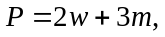
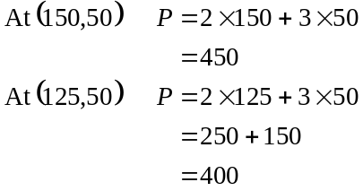
From part b.
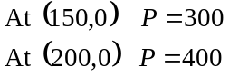
The maximum profit that can now be made is $450.
(1 mark)
Total 15 marks

Module 4: Business-related mathematics

Question 1

- i. The amount withdrawn on 15 July 2005 was 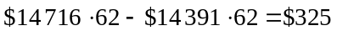
(1 mark)

  - The amount deposited on 31 July 2005 was 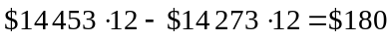.
(1 mark)

- The minimum monthly balance for July was $14 273.12. The annual interest rate was 2.4% per annum or 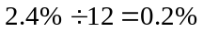 per month.
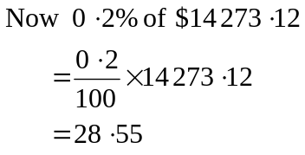

So $28.55 was received in interest.
(1 mark)

Question 2
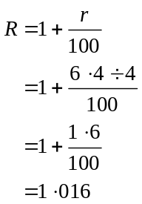
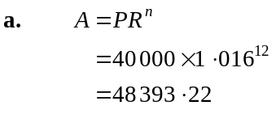
(1 mark)

(1 mark)

- Method 1 – trial and error
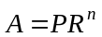 from part a.
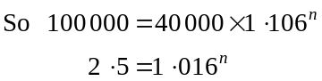
(1 mark)
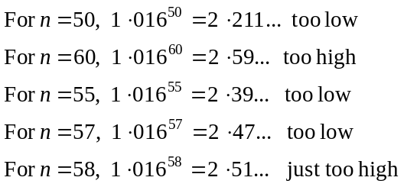
So Micaela must wait 58 quarters; to the nearest quarter, for the amount in the account to be at least $100 000.
(1 mark)

Method 2 – logarithms
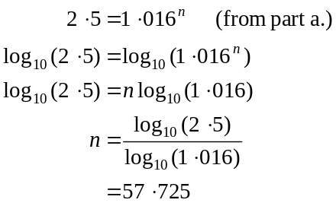
(1 mark)
So during the 58th quarter there will be $100 000 in the account. It therefore takes 58 quarters or 14.5 years to have at least $100 000 in the account.
(1 mark)

Question 3

- 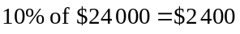
The equipment depreciates at $2 400 per year for 5 years.
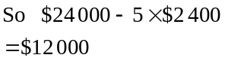
(1 mark)

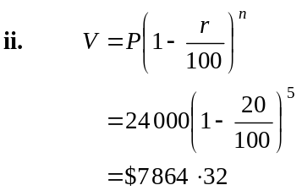
(1 mark)
(1 mark)

Question 4

- The loan is to be paid off in 12 years. To calculate Q; the monthly repayment, 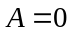, i.e. the amount owing is zero when 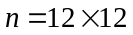, that is, after 144 quarters or 12 years.
So 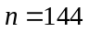.
(1 mark)
Also, 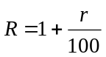
Now the interest rate per year is 9% which is 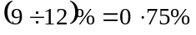 per period; that is per month.
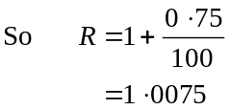
(1 mark)

- 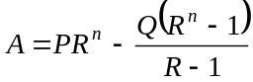
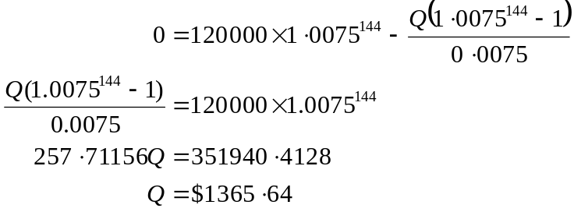
(1 mark)

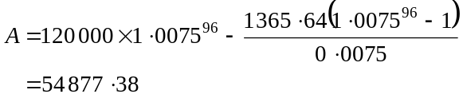
After 8 years, Micaela still owes $54 877.38. (1 mark)

- Over 12 years, Micaela pays $1 365.64 per month.
In total she pays $196 652.16. The loan was for $120 000.
So Micaela pays in interest on this loan.
(1 mark)

Total 15 marks
Module 5: Networks and business mathematics

Question 1

- The shortest length of cabling runs through workstations A, D, G, K and N and is a total of 12m.
(1 mark)

- The network does not contain an Euler circuit. An Euler circuit only exists if each vertex in the network is of an even degree. Vertex or workstation B for example has an odd degree of 3 as does E, F and so on.
(1 mark)

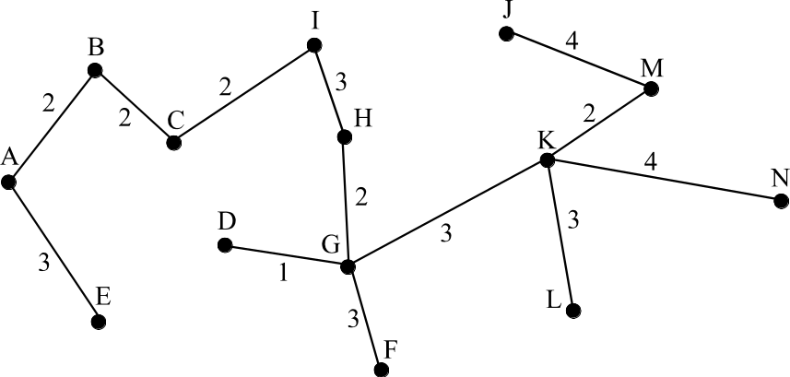
- i

(2 marks)

- .
(1 mark)

Question 2

- Immediate predecessors of activity M were E, F and I. (1 mark)
On the network below on each node are two numbers.

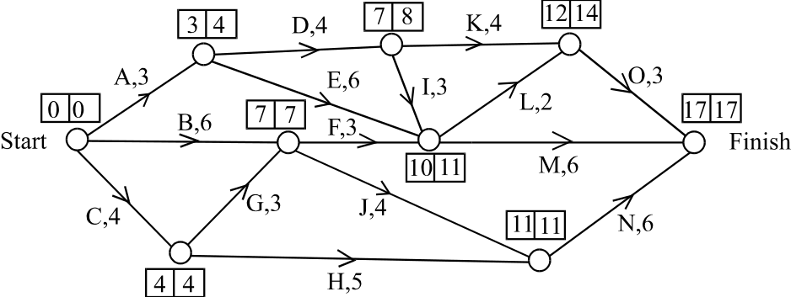

The first is the earliest start time and the second is the latest start time.
The earliest start time for activity F was 7 days. (1 mark)
The latest start time for activity K was 10 days.
(1 mark)

- The critical path is C, G, J, N.
(1 mark)

- Minimum time required to complete the project is 17 days.
(1 mark)
- Slack or float time for activity K is 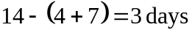.
(1 mark)

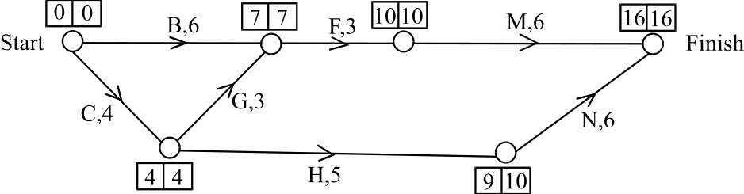

(1 mark)
The critical path is C, G, F, M.
(1 mark)

- i. Cut 1 day from activity G and 1 day from activity M. It is pointless to reduce activity B since it is not on the critical path and even if it is reduced by 2 days, activities C and G still take 6 days after G is reduced by 1.
Similarly it is pointless to reduce activity N by 1 day since it is not on the critical path and activity M can be reduced by only 1 and it is on the critical path.
The maximum number of days that can be cut is 2.
(1 mark)

- The lowest cost to achieve this is .

(1 mark)
Total 15 marks

